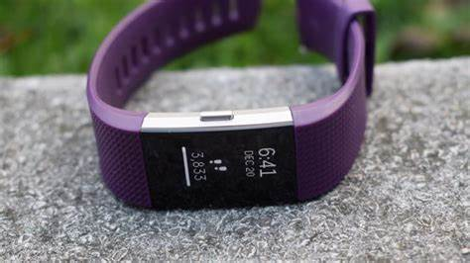Fitbit

Description: **Fitbit** is a popular brand known for its **affordable, user-friendly fitness trackers** and smartwatches that focus on health, fitness, and wellness. Fitbit devices are designed to help women track their daily activities, exercise, sleep, and overall health with an emphasis on ease of use and integration with the **Fitbit app**. Whether you're looking for a simple fitness tracker or a more advanced smartwatch, Fitbit has a variety of models to suit your needs.

The **Fitbit Charge** series is one of the most popular lines for women. The **Charge 5** is the latest model, offering a **sleek design with a color touchscreen**, built-in **GPS**, and a **daily readiness score** that measures how prepared your body is for exercise based on your activity, sleep, and heart rate. It also includes advanced health features like **stress management, sleep tracking, heart rate monitoring**, and **ECG (electrocardiogram)** capabilities, making it an excellent choice for women focused on fitness and wellness.